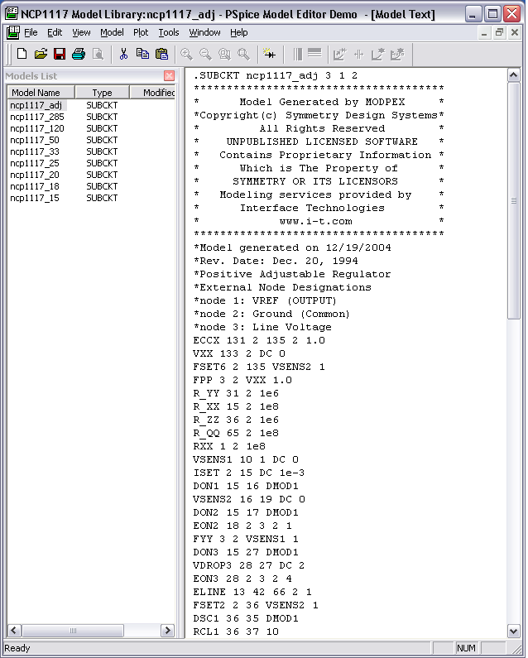
PSpice Model Editor, Model Library- code that makes up a model; this library has several models in it.

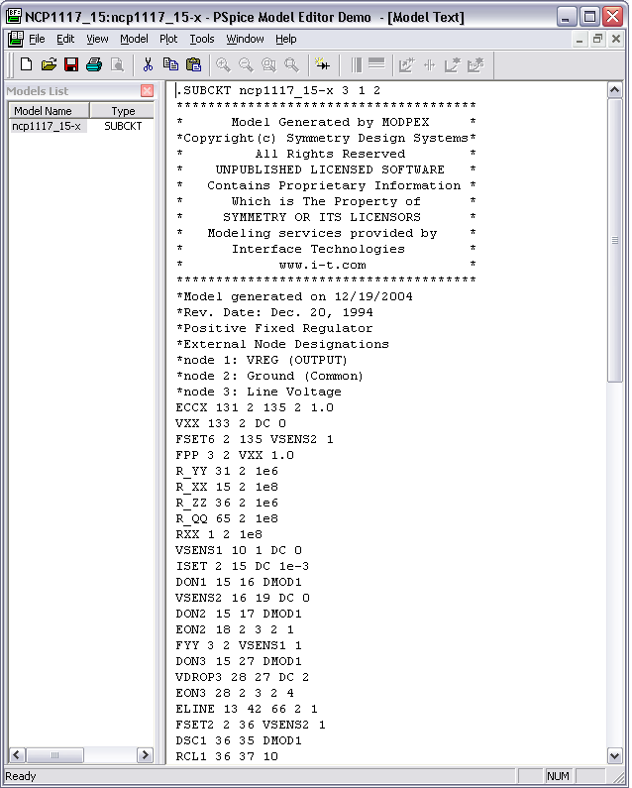
This model library has only one model in it.

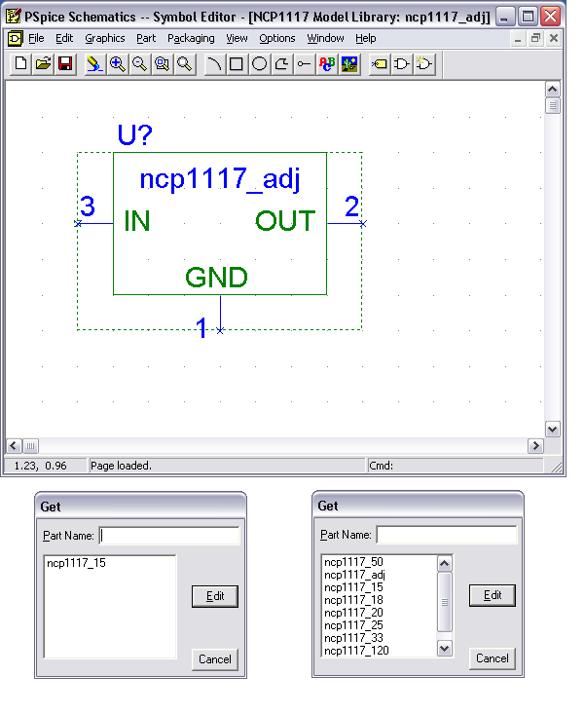
Pspice Symbol Editor, Symbol Library- picture that represents the model; like model libraries, symbol libraries can contain either one symbol or several symbols.

Schematic Editor- circuitry that features a certain part, this one shows the ncp1117_adj.
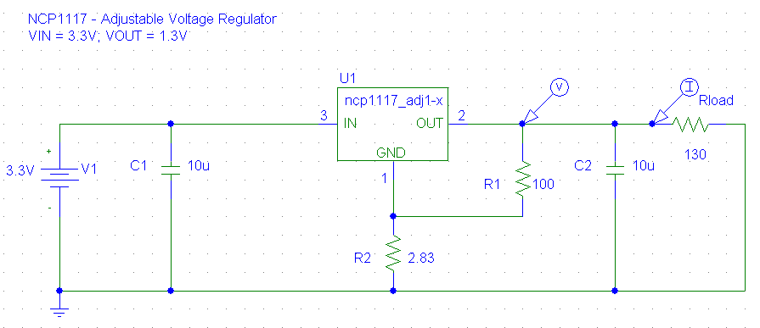

Instructions for installing models:

This procedure can be followed for adding models to new schematic files as well as adding models to schematic files that have already been started.

1. Once the model library and symbol library are saved to disk, open the PSpice Schematic Editor. Select Analysis, and then select Library and Include Files.

2. Select Browse to look for the Model Library that contains the model that is to be used in the schematic; open the Model Library; select Add Library and then OK.

Add Library adds the Model Library to the list of Library Files to be used in the schematic that is currently open.

Add Library* should be selected if this Model Library is to be used in all schematics.

3. Next, select Draw and then Get New Part. Under Part Name, type the name of the part that is to be added to the schematic. Select Place and Close to add the part to the schematic.

The part is now ready to be used in the Schematic Editor.

